Perran-ar-worthal

Local History Group

**Tues 21st Jan 2025**

7.30pm at the Perranwell Centre

**The Home Guard Auxiliaries 1940 - 44**

**‘Churchill’s Secret Army’**

**Perranwell Patrol Group**

Speaker: **Neil Roberts** (St Agnes Old Cornwall Society)

Neil is a former serving member of the Royal Air Force, who has always held a fascination for social history especially during WW2. He is the author of several books about the war in this area and has carried out extensive research on the subject.

The Home Guard Auxiliary units were highly secret groups specially trained in using irregular warfare in response to possible invasion.

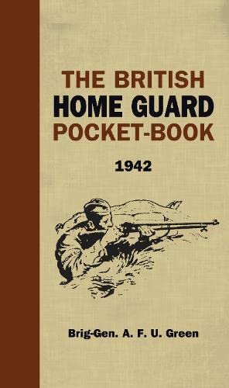

Do come and join us for what promises to be an interesting talk

Membership £6 per annum. Meetings: members £1 non members £4